

Global Connect Project

<Architecture Overview>
<IoT Sensor Network LPWAN>

www.paradigma.cl
info@paradigma.cl

OCTOBER 9, 2018

This document is confidential.

Content
Global Connect Solution 2
Discovery of a Limitation 2
Abstract 3
IoT and LPWAN 3
Some LPWan solutions today 5
LoRa/LoraWan 5
Sigfox 6
Weightless 7
Proposed extended Solution 8
Limitations 11
Work Cicle and Collitions 11
Numbers of Devices 11
Distance to the Gateway 11
Identification and security keys 11
Pilot Test 11
Scenarios 11
Measurements 11
Hardware 12
Connectivity 12
Location 12
Storage 12
Software Platforms 12

Global Connect Solution

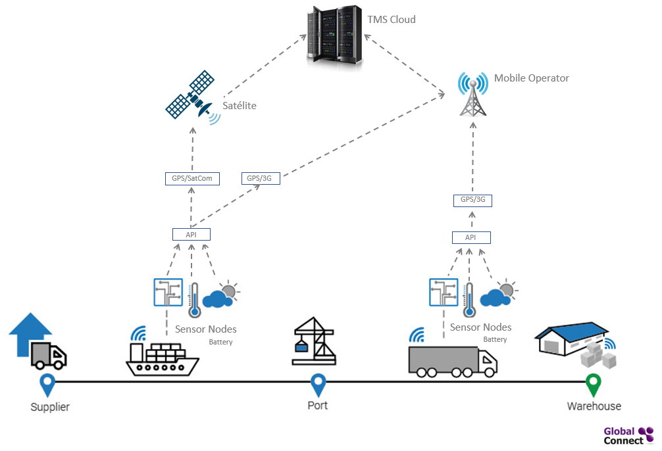
In the Global Connect Project solution, it is indicated that each container has the capacity to send the captured data of the sensors using the TMS protocol, via satellite or mobile telephony.

Messages are sent via the current 3G/4G global networks without data connection, fast and reliable without any need of roaming data, using phone calls in an end-to-end direction. For example, a container calls different predefined virtual numbers in TMS switch, the call hung-up before taken/received and the SIM-card in the container will never be debited any “data” cost. The method of identification of each container are both the Satellite and Mobile Telephone Number associated to each sensor capture node.

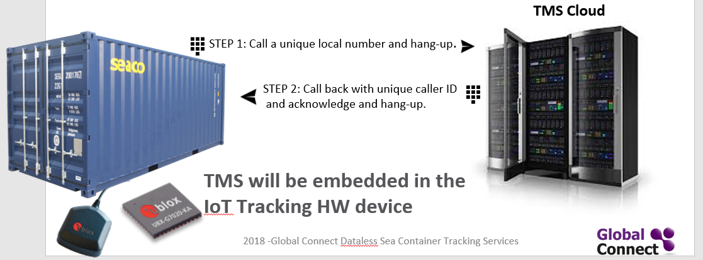

Discovery of a Limitation

Trying to undersand the real situation of transmission during the transport of containers we found that when it is done with trucks the proposal works well. But during the transport of containers in a ship a restriction is forseen. The restriction refers as the containers are stacked, and there is no control over where they will be stacked. The ships can have between 500 and 18,000 containers as shown in the following images.




We do not have the assurance of transmission during the shipment, due to high possibility of getting signal blocked when tries to reach a satellite or mobile telephony operator, especially in the containers inside the pile or inside the ship.

In view of this problem, and thinking about the scalability of the solution and the market, we made a study to solve the problem, and made some changes in order to be sure that the solution was scalable.

The proposal of the solution is presented below.

Abstract

IoT and LPWAN

The term Internet of Things (IoT) is used to indicate an advanced connection of devices, systems and services that goes beyond the traditional M2M (machine to machine) and covers a wide variety of protocols, domains and applications.

IoT offers new and innovative ways to manage and monitor remote operations. It allows to have eyes and ears in remote places, constantly feeding applications and data warehouses with information. The low cost allows you to observe and manage activities that were previously out of reach. With the Internet of Things, it is also possible to collect information about events that were once invisible, such as obtaining online data on the temperature, humidity, carbon dioxide inside a container that travels in the middle of the ocean, in a container ship.

On the other hand, a low-power wide-area network (LPWAN) or low-power wide-area (LPWA) network or low-power network (LPN) is a type of wireless telecommunication wide area network designed to allow long range communications at a low bit rate among things (connected objects), such as sensors operated on a battery.

The requirements that devices and communication networks must meet for the implementation of the IoT are:

- Low energy consumption.
- Reduced size.
- Total mobility in communications.
- Have location systems.
- Secure communications. The confidentiality and integrity of the transmitted data must be ensured.
- Wide-ranging connection networks that accept a large number of devices.
- Easy to implement and manage, reliable and robust.
- Low production cost of the final devices, as well as network elements.

LPWAN networks work in the ISM band (Industrial, Scientific and Medical). The use of these frequency bands is open to everyone without the need for a license, respecting the regulations that limit the levels of transmitted power.

Although this band belongs to the range of short-range devices, it is being used in low-power wide-area network (LPWAN) wireless telecommunications networks, designed to allow long-range communications at low bit rates between objects (connected objects).

Within the free bands there are several possibilities:

- 2.4 GHz band using WiFi, Bluetooth or Zigbee
- 5 GHz band using WiFi
- 868 MHz band with option to use Zigbee, LoRa, Weightless or Sigfox
- 434 MHz band
- RFID frequencies (13.56 MHz, 125 kHz, etc…)

The LPWAN ecosystem includes suppliers such as Semtech Corporation (USA), LORIOT (Switzerland), NWave Technologies (United Kingdom), SIGFOX (France), WAVIoT (Texas, USA), Actility (France), Ingenu (San Diego, USA), Link Labs (Maryland, USA), Weightless SIG, and Senet, Inc. (Portsmouth, United Kingdom), ResIOT (Italy) and others as service providers and companies. Other stakeholders in the LPWAN network market include telecommunications operators such as Vodafone (U.K.) and Orange (France), among others, that integrate these smart devices and sell them to end users to meet their unique business requirements.

Some LPWan solutions today

LoRa/LoraWan

LoRa (Long Range) is a patented digital wireless data communication IoT technology developed by Cycleo of Grenoble, France. It was acquired by Semtech in 2012, which holds the IP for LoRa transmission methodology.

LoRa transmits over license-free sub-gigahertz radio frequency bands like 169 MHz, 433 MHz (Asia), 868 MHz (Europe) and 915 MHz (North America). LoRa enables very-long-range transmissions (more than 10 km in rural areas) with low power consumption.

The LoRa technology of Semtech offers features such as high reception sensitivity and spread spectrum modulation that allows these radios to drastically increase the range at low bit rates, while still operating with a battery output power (20dBm / 100mW) and mode of operation. ultralow power rest. These radios are also compatible with the FSK modulations, but they are intended to be used with the LoRa (Long Range) modulation technology.

Following are the advantages of LoRa:
- High tolerance to interference
- High sensitivity to receive data (-168dB)
- Based on chirp modulation
- Low Consumption (up to 10 years with a battery)
- Long reach 10 to 20km
- Low data transfer (up to 255 bytes)
- Point-to-point connection
- Working frequencies: 915Mhz America, 868 Europe, 433 Asia

Following are the disadvantages:
- It can be used for applications requiring low data rate i.e. upto about 27 Kbps.
- LoRaWAN network size is limited based on parameter called as duty cycle. It is defined as percentage of time during which the channel can be occupied. This parameter arises from the regulation as key limiting factor for traffic served in the LoRaWAN network.
- It is not ideal candidate to be used for real time applications requiring lower latency and bounded jitter requirements.

LoRa may be suitable for use in discrete applications such as container ships where a mobile network is not necessary.

LoRaWan refers to broad public networks based on LoRa and consists of LoRa Gateway, servers and end devices.

Sigfox

SigFox is a narrowband (or ultra-narrowband) technology. It uses a standard radio transmission method called binary phase-shift keying (BPSK), and it takes very narrow chunks of spectrum and changes the phase of the carrier radio wave to encode the data. This allows the receiver to only listen in a tiny slice of spectrum which mitigates the effect of noise. It requires an inexpensive endpoint radio and a more sophisticated basestation to manage the network.

SigFox communication tends to be better if it’s headed up from the endpoint to the basestation. It has bidirectional functionality, but its capacity going from the base station back to the endpoint is constrained, and you’ll have less link budget going down than going up. This is because the receive sensitivity on the endpoint is not as good as the expensive basestation.

Rather than set up your own LoRa network, Sigfox is an existing network set up by the self-same company. You can only use Sigfox chips in a location where there is an existing network set up. After you’ve registered and paid, you can join the network, send and receive data.

You just do the Connected Devices part and then send/receive data via the cloud interface.

The nice thing about SigFox is you don’t have to create a network, manage gateways, etc. Since the receivers are permanently installed, they’re very fancy and powerful and let you have less expensive and more powerful chips.
The big constraint is the very tiny message bandwidth: only 140 x 12 byte message per day upload, and 4 x 8 byte per day download. Like, really limited.
Following are the advantages of Sigfox:
- Backend network taken care of
- Very long range (a few km in cities, up to 40km in rural areas with directional antennas)
- Very low power

Following are the disadvantages of Sigfox:
- Paid subscription service
- Ultra slow: 100 bytes/sec
- Not available everywhere - check if there’s a network provider where you are deploying
- 140 x 12-byte upload and 4 x 8-byte download messages a day
- Fixed frequency per location

Weightless

Weightless is a set of LPWAN open wireless technology standards for exchanging data between a base station and thousands of machines around it. These technologies allow developers to build Low-Power Wide-Area Networks.
In an initiative reflecting the strong market traction of Weightless-P, the Weightless SIG’s has renamed the technology simply “Weightless” and has made it its core focus moving forward.
Originally, there was three published Weightless connectivity standards Weightless-P, Weightless-N and Weightless-W. Weightless-N was an uplink only LPWAN technology. Weightless-W was designed to operate in the TV whitespace. Weightless (Weightless-P) was the true winner with its true bi-directional, narrowband technology designed to be operated in global licensed and unlicensed ISM frequencies.
Weightless is managed by the Weightless SIG, or Special Interest Group, which was revealed to the public on 7 December 2012. The intention is that devices must be qualified by the Weightless Special Interest Group to standards defined by the SIG. Patents would only be licensed to those qualifying devices; thus, the protocol, whilst open, may be regarded as proprietary.
Following are the advantages of Weightless:
- Why com Firmware-Over-The-Air
- Very Spectrum Efficient (12.5Khz/channel)
- Bidirectional Communication
- Synchronous network - Highly Scalable
- Open Standard
- Robust FEC Convolutional Coding
Weightless?

Weightless-P and SigFox are similar from a technology perspective, but they’re very different from a go-to-market perspective. Weightless is a standard, so it’s up to another company to create an IoT solution around it. On the other hand, SigFox offers a complete out-of-the-box solution.
Weightless-P and LoRa offer very different means to an end from a technology perspective. But functionally, LoRaWAN and Weightless are very similar, particularly because both are uplink-focused data systems.
If LoRa is not attractive to a user because the radio silicon is solely sourced from Semtech, Weightless is a good alternative of something based on an available standard. The challenge for engineers or firms will be determining how to build an IoT system around it.

Proposed extended Solution

The proposed extended solution consists of two extra elements:

- Gateways. They receive the transmissions made by multiple end devices and forward them to the network servers.
- DSNS server (Domain Sensor Name Server). Responsible for the reception and processing of the information that comes from the final devices, as well as the management and configuration of the network and the final devices.

The solution consist of a star-on-star network topology, which uses sensors that send data captured through gateways, using the LPWPAN protocol, with the interaction of a DSNS Server.
The network formed by the final devices and the gateways is star type with a single jump (from Gateway to Server). This type of networks is very easy to implement and manage (as routing elements are not necessary). In addition, the gateways, not acting as routers, do not retransmit traffic from other gateways with the consequent energy savings. Simplicity and energy saving are essential requirements in the IoT implementation networks.
In summary, devices in the network are asynchronous and transmit when they have data available to send, and it has not been able to communicate by mobile or satellite telephony. Data transmitted by an end-node device is received by gateways, which forward the data packets to a centralized network server. The network server filters duplicate packets, performs security checks, and manages the network. Then, the data is then forwarded to server TMS.

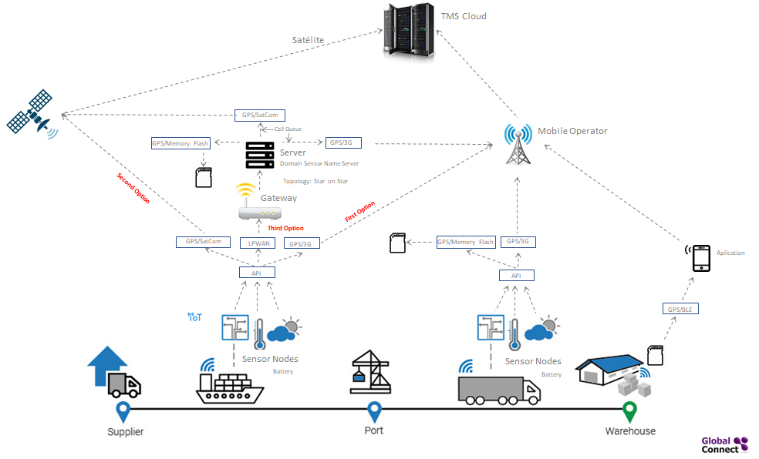
Proposed extended solution

The sensors, batteries, the flash memory, the API module for the administration of the data received from the sensors and the TMS protocol are installed inside of a container. On the outside of the container are installed the antennas for the 3G, LPWAN GPS, SATCOM and BLE.

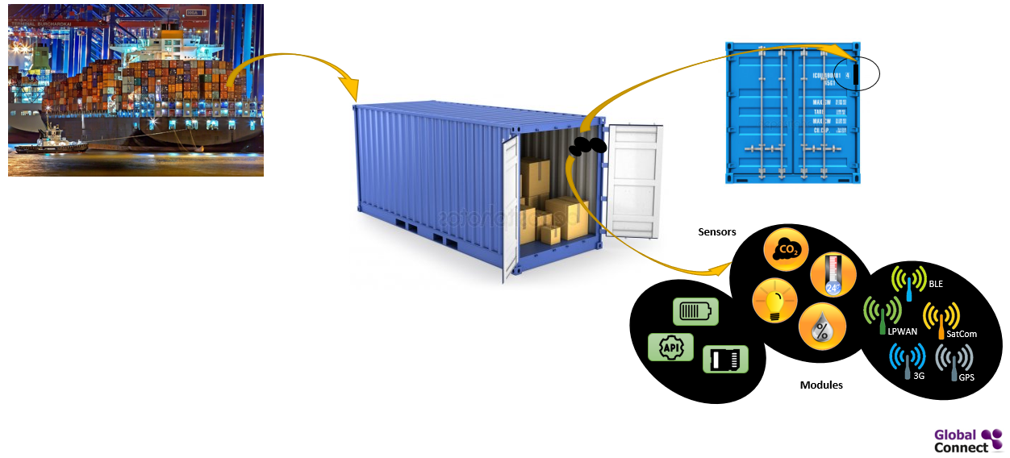
Possible location of sensors and modules in the container

In the container’s ship is installed the DSNS server. The server contains also 3G, SATCOM and GPS modules, as well as flash memory. In addition, gateways are installed in specific places.

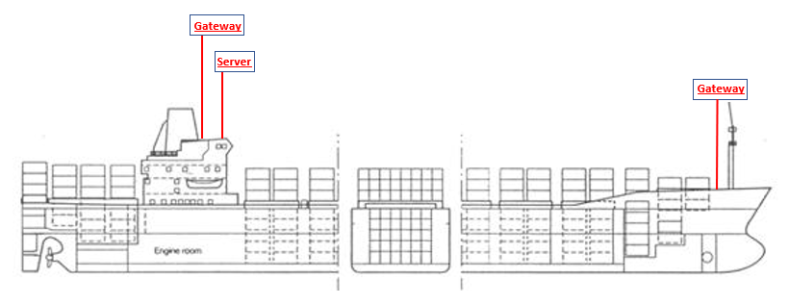
Possible location of gateways and server in the ship

On the ship, the sensor capture node, after it has not been able to communicate by mobile or satellite, recognize that they are in an LPWAN network, therefore, they forward the data to the nearest gateway (previously the API transforms the received bits and formats them according to the frame needed by the TMS server). The Gateways retransmit the formatted data that comes from the end devices to the DSNS network server. In this way the base stations work as bridges which also results in a very simple design of the network and its components. Then, the server transmits the data via satellite telephony or mobile operator using the Innotel TMS protocol (there is a call queue), in case of not having coverage the data is stored in flash memory, until it achieves adequate coverage and can be retransmitted.

Additionally, to the the Satellite and Mobile Telephone Number associated to each sensor capture node, the LPWan address has be considered, as the DSNS server is the one that is sending the collective information from all the containers. The Satellite and Mobile Telephone Number of the DSNS server plus the LPWan Address identifies each container.

On the ship, the sensor capture nodes must necessarily be connected to a Gateway. In addition, to be able to join the network and take advantage of the benefits of the protocol, each node must send a series of identification and security keys, all the nodes work in a star connection, the same nodes, even when in motion, connect to the gateway closer and with better quality of communication, very similar to how a mobile network works.

In the transport by land, the nodes recognize that they are not in an LPWAN network, therefore, the data is sent via 3G (if there is service coverage) using the TMS protocol (previously the API transforms the received bits and formats them according to the frame that the server needs TMS). In case of not having coverage, the formatted data is stored in flash memory, until it achieves adequate coverage and can be transmitted.

In case the data could not be transmitted, at the moment the container is opened, and if there is data stored in the flash memory, it will be downloaded through a BLE connection to a smartphone through an application installed on a telephone. Which later can be exported to the central station (TMS).

In summary, the implementation considers three options:

- Ideal condition, always online: There is always a connection by telephony, either by satellite or mobile operator. Accordingly, the data is transmitted online using the Innotel TMS protocol.
- Mixed condition, online and offline: If there is communication, the data is transmitted to the central station (TMS), if the system can not communicate, either by satellite or mobile operator, it saves the data in flash memory. Once the container is opened, and if there is data stored in the flash memory, it will be downloaded to a smartphone through an application installed on a telephone and the BLE connection. Which later can be exported to the central station (TMS).
- Condition always offline: When the container is open, and if there is data stored in flash memory, it will be downloaded via a BLE connection to a smartphone through an application installed on a phone. Which later can be exported to the central station (TMS).

Limitations

Work Cicle and Collitions

In networks where low-speed transfers prevail, performance is limited by the number of collisions, while in networks where high-speed transfers prevail, performance is limited by the restrictions imposed by the regulations regarding the work cycle (due to the limitation in the number of frames per day that a device can emit).

Numbers of Devices

Another factor that limits the capacity of the network is the number of devices. The increase of devices has a strong impact on the performance of the network.

Distance to the Gateway

A highly scalable network is needed so that with a single gateway it can connect a very high number of devices as long as the speed and capacity requirements are low. Then, in order for network performance to be unaffected, most devices should be close to the gateway, especially those with high traffic.

As the number of devices that are far from the gateway increases, the reliability of the network decreases significantly.

Identification and security keys

The unplanned use of surveys can limit the scalability of the network since the gateways are also limited by the restrictions of the work cycle and the continuous issuance of recognition frames can limit the number of frames of orders or data that the gateway can send per day.

Pilot Test

Scenarios
There are two scenarios to evaluate in the pilot test:
- The Global Connect Project solution, it is indicated that each container has the capacity to send the captured data of the sensors using the TMS protocol, via mobile telephony (first option) or satellite telephony (second option).
- Extension to the original solution. It consist of a star-on-star network topology, which uses sensors that send data captured through gateways, using the LPWPAN protocol (third option), with the interaction of a DSNS Server. The server transmits the data via satellite telephony or mobile operator using the Innotel TMS protocol (there is a call queue), in case of not having coverage the data is stored in flash memory, until it achieves adequate coverage and can be retransmitted.

Measurements
For the pilot test we will measure the following indicators:
- Penetration: Capacity of the IoT solution to carry the data to the destination
- Autonomy: Battery life
- Reach: Level of reach of the container information during transport from origin to destination.
- Opportunity: Elapsed time for the reception of the information.
- Robustness: Capacity to face contingencies during transportation.
- Material resistance: If the sensor capture node device is capable to support its use and travel.

Hardware
The hardware devices with which we will measure or interact are:

In the container:
- Four sensors: Humidity, Temperature, Carbon Dioxide, CO2, or Light
- Batteries
- Flash memory
- Modules: 3G, SatCom, GPS, BLE, LPWan, API

On the ship:
- Two Gateways
- A Server with 3G modules, SatCom, GPS, LPWan

Connectivity
The communications are:
- Wireless (LPWAN)
- 3G
- SatCom
- Bluetooth (BLE)

Location
The means of localization are:
- GPS

Storage
The storage media are:
- Flash Memory

Software Platforms
To process the data collected by our sensors and store them we have to program:
- API that must be programmed in the devices installed in the containers, the received bits must be formatted according to the frame that the TMS server needs, the CallID and the location must be added to the frame.
- Call queue on the server.
- Application in the smartphone to import and export data (formatted according to the frame that the TMS needs) from the flash memory.

